Nginx Fundamentals for Window

This document shows some basic information about nginx.

# Installing nginx

**General information**

Referring to <http://en.wikipedia.org/wiki/Nginx> : Nginx (pronounced "engine-x") is an open source reverse proxy server for HTTP, HTTPS, SMTP, POP3, and IMAP protocols, as well as a load balancer, HTTP cache, and a web server (origin server).

Referring to <http://wiki.nginx.org/Main> : Nginx (pronounced engine-x) is a free, open-source, high-performance HTTP server and reverse proxy, as well as an IMAP/POP3 proxy server.

At this point, we use ***nginx-1.6.1*** to install. You can download it at: <http://nginx.org/en/download.html>.

You download it as a zip file. You can extract it at any your destination folder such as:

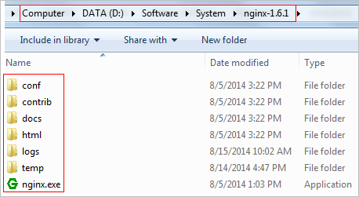

Now, you can use it for your jobs.

# Start / stop nginx

You can refer to <http://nginx.org/en/docs/windows.html> to view some information about using nginx for Window.

**Starting nginx**

After extracting, nginx provides you an executed file is nginx.exe. In Window, you can execute it by using double-click function or using command line such as:

*{nginx_root}>start nginx*

Note: nginx uses default port 80 so you must ensure that there is not any program using this port to start nginx.

You can use browser to check whether or not nginx is working as:

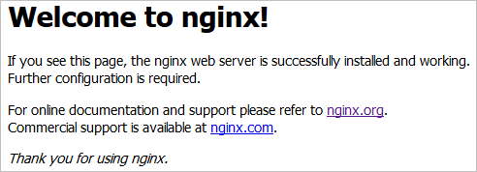

Now, you can use nginx to control your sites.

**Stop nginx**

You can use one of two ways to stop nginx

*{nginx_root}>nginx –s stop 🡺 Fast shutdown*

*{nginx_root}>nginx –s quit 🡺 Graceful shutdown*

At the current, I don’t know any method to check whether or not nginx is running by using command line. You can check it via browser such as: <http://localhost:80>.

# Configuring new site with nginx

In the “conf” directory of the folder that contains nginx, you will find nginx.conf file. Modifying it to add new configuration for your site.

Sample, I have single page application that is written by AngularJS. The default page is index.html. I want to run it at port 9000. Below code is the configuration for my site:

*server {  
 listen 9000;  
 server_name localhost;  
 location / {  
 proxy_set_header X-Real-IP $remote_addr;  
 proxy_set_header X-Forwarded-For $remote_addr;  
 proxy_set_header Host $http_host;  
  
 # If not search enging pass static  
 root "d:/Data/Company/R&D/AJAX Apps crawlable/demoSPA/lawsonry_nginx/app";  
  
 try_files $uri $uri/ /index.html;  
 }  
}*

You need stop and start nginx to apply new configuration. Or, you can reload configuration by this way:

*{nginx_root}>nginx –s reload*

After that, you can test your site such as: <http://localhost:9000>.

You can refer to <http://wiki.nginx.org/Configuration> to view more configuration setting with nginx.